
WEEK 5 GROUP J PROGRESS REPORT
Agent Architecture and Bounded Autonomy
Course: BSE4104 Emerging Trends in Software Engineering
Project: Software-Engineering QA Agent
Group: Group J
NAME | STUDENT NUMBER | REGISTRATION NUMBER
Karagwa Ann Treasure | 2300709034 | 23/U/09034/PS
Ayan Mustafa Abdirahman | 2300722948 | 23/X/22948/EVE
Wanyana Selina Masembe | 2300701529 | 23/U/1529
Amabe Junior Humphrey | 2300705942 | 23/U/05942/PS
Akanga Andrew | 2300705555 | 23/U/05555/PS
Date: 2 October 2026

1. OVERVIEW
Week 5 focused on turning the components built in Weeks 1 to 4 into one goal-directed, multi-step workflow that chooses among approved next actions and stops safely. The retrieval pipeline, model proposal format, citation validator, tool dispatcher, approval gate and sandboxed tools already existed; this week the team connected them through a bounded agent loop that repeats sense, plan, validate, act and observe until the task is complete, a human decision is needed, or a stop condition is reached.
The team kept the project's central design principle: the model proposes one action per turn, while deterministic code decides whether that action is grounded, permitted, approved and allowed to continue, and every step is recorded for review. The table below maps the brief's Week 5 deliverables to the repository evidence and the responsible member.
Week 5 deliverable | Repository evidence | Owner
Agent Architecture Diagram | docs/architecture/l5-agent-loop.png and the L5 page of the drawio architecture file | Member 2
Agent Task Contract (goal, tools, state, limits, stop conditions) | src/agent/task_contract.yaml, task_contract.py, task_adapter.py | Member 3
Working bounded agent workflow | src/agent/loop.py with src/agent/stop_conditions.py | Members 2 and 1
Three execution traces, including failure and recovery | evidence/traces/week5-run-1-completed.json, -2-failure-recovery.json, -3-stop-condition-halt.json | Member 4
A saved log of every run | src/observability/run_logger.py writing to evidence/traces/runs/ | Member 5
Week 5 progress report | This document | Group

2. AGENT ARCHITECTURE
Figure 1 shows the Week 5 agent loop. The loop owns the order of the steps but none of the policies: the context sensor, planner, stop evaluator and trace sink are injected, so each member's component can be built and tested separately and replaced without changing the loop.
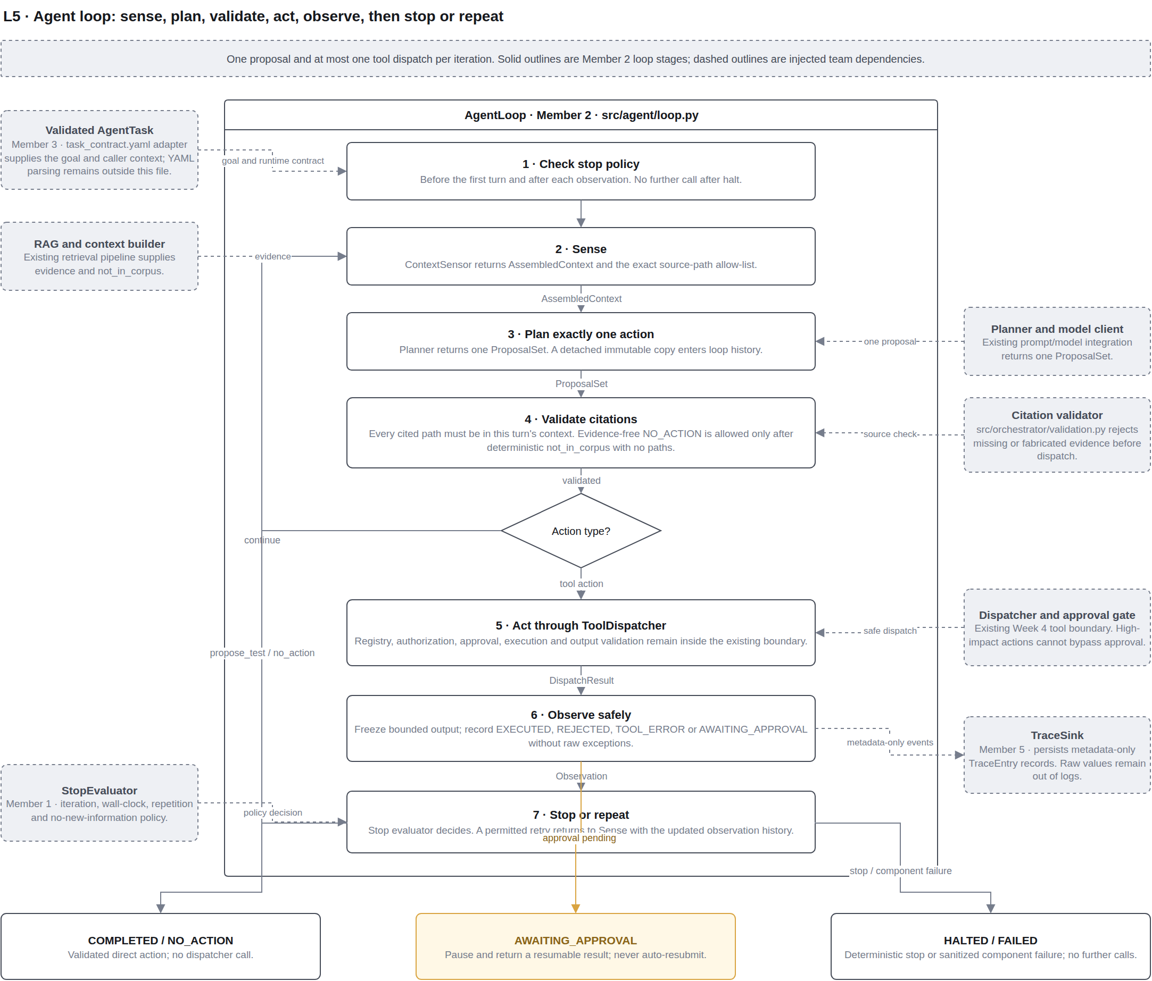
Figure 1: L5 agent-loop architecture (Member 2). Solid stages belong to the loop; dashed boxes are injected team components.
Each turn follows a fixed lifecycle:
- Stop check: the stop evaluator runs before the first turn and after every observation.
- Sense: retrieval and the context builder supply evidence and the exact list of sources that may be cited.
- Plan: the planner returns exactly one proposed action.
- Validate: every citation is checked against this turn's sources before anything else happens.
- Act: a proposed test or no-action finishes the run; a tool action goes through the dispatcher at most once.
- Observe: a bounded, sanitized observation is recorded and the loop stops, pauses or begins another turn.
A run ends in one of five explicit states: COMPLETED, NO_ACTION, AWAITING_APPROVAL, HALTED or FAILED. A pending approval pauses the run so that a human can decide, and the caller resumes it afterwards; the loop never retries or approves a request by itself.

3. TEAM CONTRIBUTIONS

Member 1: Project and Requirements Lead
Member 1 audited whether the multi-step task matches what the project charter promised, and implemented the stop conditions. The audit confirmed that the contract's four tools and its limits (5 iterations, 120 seconds) match the charter's scope. It found that US-9's acceptance criterion named only the iteration cap, although the design notes and tests described four conditions, so the criterion was widened in the charter document to cover all four.
The implementation, src/agent/stop_conditions.py, provides StopConditionPolicy, which checks, in a fixed order, a hard iteration cap, a wall-clock budget, an identical repeated call, and a step that yields no new information. Member 1 also replaced the deliberate placeholder in task_adapter.py so that build_stop_evaluator now returns the real policy, added 19 unit tests and a demonstration script, and recorded an open item: the US-5 failure-summary type is not yet used anywhere in the workflow.

Member 2: Application and Integration Lead
Member 2 implemented the bounded agent loop in src/agent/loop.py. AgentLoop coordinates one session using injected components and enforces four safety rules: exactly one proposal per turn, at most one dispatcher call per turn, citation validation before any action, and approval-pending results that pause rather than retry. Failures in any injected component stop the loop with a fixed, sanitized failure value instead of raw error text.
Member 2 also made one narrow change to the citation validator: an evidence-free NO_ACTION is accepted only when deterministic retrieval has confirmed that the corpus holds nothing relevant, so the model is never pushed to invent a citation. The work includes the L5 architecture diagram, tests/integration/test_agent_loop.py and an integration document.

Member 3: AI Engineering Lead
Member 3 produced the Agent Task Contract. src/agent/task_contract.yaml states the agent's goal (quoted from the propose_action v1.1 prompt), its four permitted tools and its limits. A typed AgentTaskContract and the loader in task_contract.py reject unknown keys, unknown or duplicate tools, and invalid limits, using a safe YAML parser; PyYAML was added to requirements.txt. task_adapter.py turns the contract and the caller's identity into the AgentTask the loop consumes.
Member 3 added 7 contract tests and the adapter tests, and identified that a duplicate copy of a test-log fixture was the cause of a long-standing retrieval test failure, which was then removed.

Member 4: Quality and Security Lead
Member 4 wrote tests/test_stop_conditions.py (16 tests). The tests check the stop policy's decisions in isolation and, separately, check that each of the four conditions really halts the real agent loop, including a direct test of US-9's acceptance criterion that the halt appears in the trace.
Member 4 also generated the three required execution traces through the real loop: a completed run, a run in which a tool call fails and the agent recovers, and a run halted by a stop condition. A test regenerates and checks them so the evidence cannot drift from the code. Because the stop policy was not yet available, Member 4 first used a clearly labelled stand-in, then swapped in Member 1's real policy; all tests still passed and the regenerated traces were byte-for-byte identical.

Member 5: DevOps and Documentation Lead
Member 5 implemented the run logger, src/observability/run_logger.py, which is the loop's trace sink. It saves every run to evidence/traces/runs/ as one JSON Lines file per run, plus an index row recording how each run ended. A failed write stops the loop, so the agent never acts without a record; credential-like text is redacted before saving; and a run that pauses for approval and resumes stays in one file. scripts/show_run_log.py prints a saved run as a timeline.
Member 5 also improved the Week 4 approval gate so that it reports a pending decision instead of blocking, which lets the loop pause and resume. Each approval now runs a tool at most once, a requester cannot approve their own request, the shared queue is locked against concurrent changes, and human decisions appear in the run log. In addition, Member 5 replaced a duplicate set of test tools with Member 3's versions, renamed the pre-commit hook so that the sensitive-data check actually runs, removed an unneeded scanner exemption, added pytest.ini, fixed out-of-date paths and rewrote the README. These changes are on the week5-save-log-to-evidence-folder branch pending merge.

4. INTEGRATION
The week's work fits together through small, named interfaces, so each member could develop and test independently:
Interface | Provided by | Used by
AgentTaskContract and build_agent_task: the goal and identity become an AgentTask | Member 3 | Member 2's loop
build_stop_evaluator returns StopConditionPolicy | Member 1 (closing Member 3's seam) | Member 2's loop; verified by Member 4
TraceSink: each step's TraceEntry is saved | Member 5 (RunLogger) | Member 2's loop
ApprovalGate: a pending result pauses the loop until resume() | Member 5 | Member 2's dispatcher and loop
Tools and sandbox: search_repo, read_file, run_tests, draft_issue | Member 3 (Week 4) | Member 2's dispatcher

5. VERIFICATION
Each member verified their own work:
- Member 1: 19 new stop-condition unit tests and updated adapter tests; the unittest suite ran 80 tests, OK; the real policy produced identical results in Member 4's four loop scenarios.
- Member 2: 40 focused tests and a wider selection of 74 tests and 116 subtests passed, together with compilation and sensitive-data checks.
- Member 3: contract and adapter tests passed; the full run reached 217 passed with no failures after the duplicate fixture was removed.
- Member 4: 16 stop-condition tests passed with both the stand-in and the real policy, and the three traces regenerated identically.
- Member 5: 18 approval-gate tests and 25 run-logger tests passed, and the demonstration produced three saved runs, one of which records a human approval.
After the week's work was merged, the complete suite was run from the repository root with python -m pytest -q: 289 tests passed with no failures (evidence/screenshots/week5/). This removes two problems recorded in earlier weeks: a retrieval test that failed because of the duplicate fixture, and collection errors caused by test files stored inside the knowledge corpus. The repository-wide sensitive-data scan also passes.

6. CHALLENGES AND RESOLUTIONS
Challenge | Resolution
The stop conditions were needed by tests before they existed. | Member 4 tested against a labelled stand-in with the agreed interface; Member 1 built the real policy as a drop-in, confirmed by identical traces.
A repository pull removed Member 1's uncommitted first draft. | The module was rebuilt against Member 4's final test file, which also aligned the two implementations.
A duplicate .log fixture broke a retrieval test and needed a scanner exemption. | The duplicate and its exemption were removed; the synthetic .txt fixture remains and all evaluation cases still pass.
The pre-commit hook file was misnamed, so the sensitive-data check never ran. | The hook was renamed to pre-commit and confirmed to block a staged .log file.
The approval gate blocked while waiting, so the loop could not pause. | The gate now returns a pending decision, and each approval is used once.
New dependencies and test discovery broke local runs (PyYAML; corpus test copies). | Members reinstalled from requirements.txt; pytest.ini limits discovery to tests/.

7. CONCLUSION AND NEXT STEPS
Week 5 delivered a bounded, inspectable agent: a task contract that states its goal, tools and limits; a loop that takes one grounded, validated action per turn; four enforced stop conditions; human approval that pauses rather than blocks; and a saved, secret-free record of every run, demonstrated by three execution traces including a failure and recovery.
The following items remain open and will be addressed as the workflow is integrated end to end:
- The loop is currently exercised with scripted sensor and planner adapters; a live retrieval sensor and model planner still need to be connected.
- The contract's tool list is not yet used to build the tool registry, and the session-ID policy is undecided.
- The US-5 failure summary is not yet produced by run_tests or used by draft_issue.
- The comment in task_contract.yaml stating that the limits are not enforced is now out of date.
Week 6 will make the workflow's state explicit, add one justified persistent-memory use case, and specify one capability as an MCP-style interface. The Week 5 safety property is that the agent may plan, but deterministic code and people decide whether it acts, when it stops, and what is recorded.

